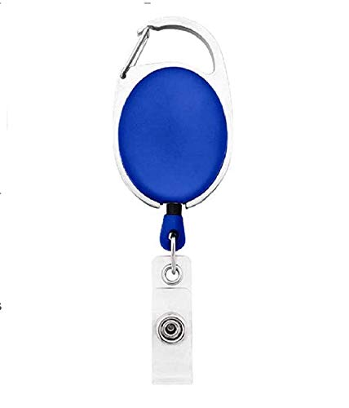



|  |  |
| --- | --- |
| **Jayavignesh** | PHOTO |
| **Dev** |
| **16-08-1997** |
| **ABC** |
| **1009752** |

Questions / Queries – Drop an email to mailmukeshkala@gmail.com